**Introduction:**

Banquet hall booking involves the process of reserving a venue space for various events such as weddings, corporate gatherings, birthday parties, and other special occasions. This process typically begins with a client's inquiry about the availability of the banquet hall for their desired date and event type. The client discusses their event requirements including the date, expected number of guests, preferred layout, catering options, and any specific requests they may have. Based on the client's requirements, the banquet hall provides a detailed proposal outlining the available packages, pricing, inclusions, and any additional services or amenities. After the booking is confirmed, the banquet hall's event coordinator or planning team works closely with the client to plan and coordinate all aspects of the event. This includes finalizing event details, such as seating arrangements, menu selection, décor preferences, audiovisual requirements, and any other special requests. On the day of the event, the banquet hall staff ensure everything runs smoothly, troubleshoot any issues that may arise, and provide assistance to the client and their guests as needed.

**Project Overview:**

This project is to develop a comprehensive booking management system for a banquet hall business using Salesforce. The system will streamline the booking process, manage event details, and provide insights into sales and revenue. Additionally, it will include features to manage catering/menu selection, DJ services, decorations, themes related to weddings, and other marriage-related services. Implement flow to ensure data integrity and prevent double bookings.

**MILESTONE 1**

**SALESFORCE**

**Activity 1: Creating Developer Account**

Creating a developer org in salesforce.

1. Go to <https://developer.salesforce.com/signup>

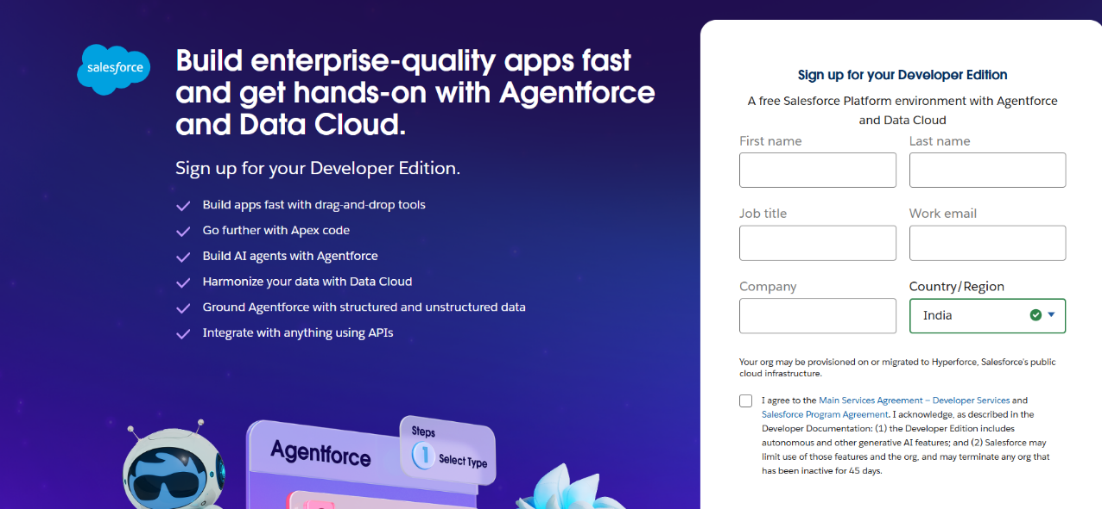 2. On the sign up form, enter the following details :

1. First name - AYESHA
2. Last name -SHAIK
3. Email -ayeshashaik272023@gmail.com
4. Role – Developer
5. Company – Gayatri degree college Tirupati
6. Country – India

**Activity 2: Account Activation:**

**Account Activation:**

1. Go to the inbox of the email that you used while signing up. Click on the verify account to activate your account. The email may take 5-10mins

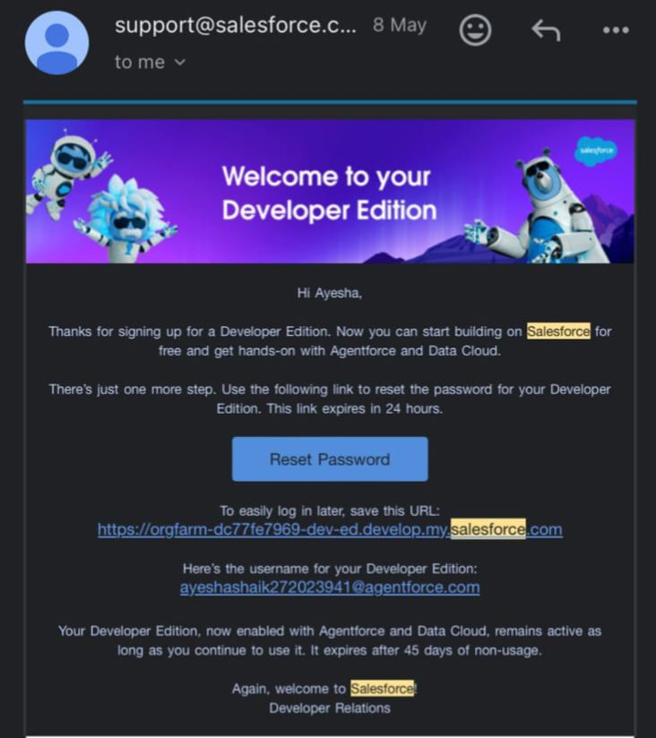

1. Click on Verify Account
2. Give a password and answer a security question and click on change password.

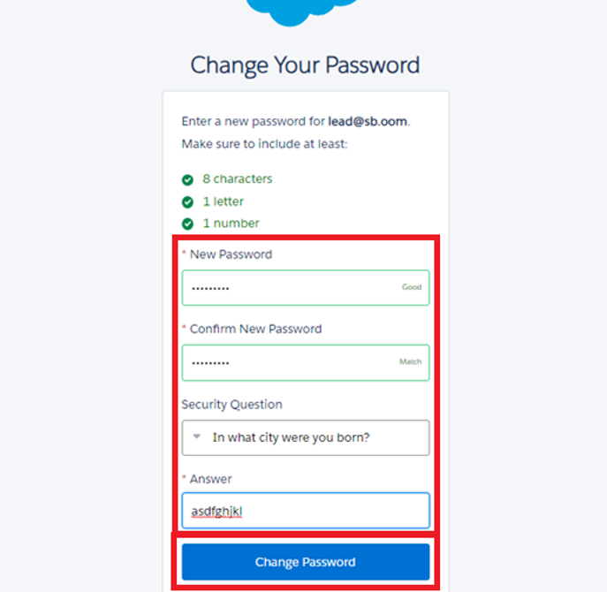

1. Then You Will redirect to your salesforce setup page.

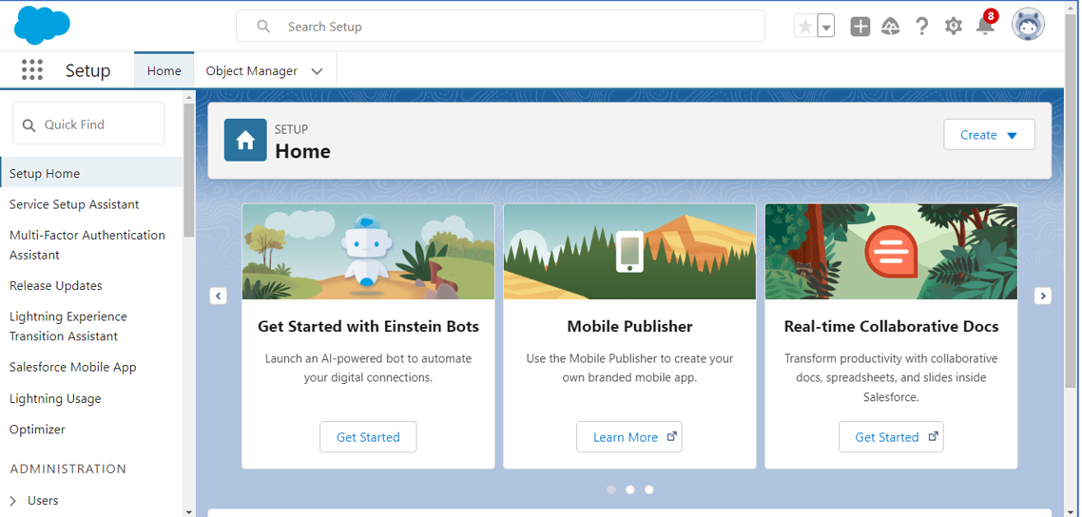

**MILESTONE 2**

**OBJECT**

**Activity 1: Creating a Banquet Hall Object**

The purpose of creating a Banquet Hall custom object is to store and manage information about Banquet Hall Bookings**.**

**To create an object:**

1. From the setup page.
2. Click on object manager.

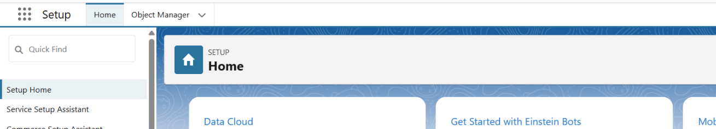

1. Click on Create --> Click on Custom Object.
2. Enter the label name-->Banquet Hall
3. Enter Plural label name --> Banquet Halls

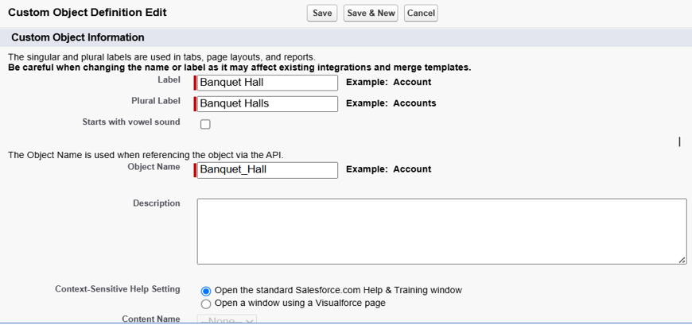

1. Enter Record Name --> Customer Name
2. Select Data Type as Text.
3. Select Allow reports.

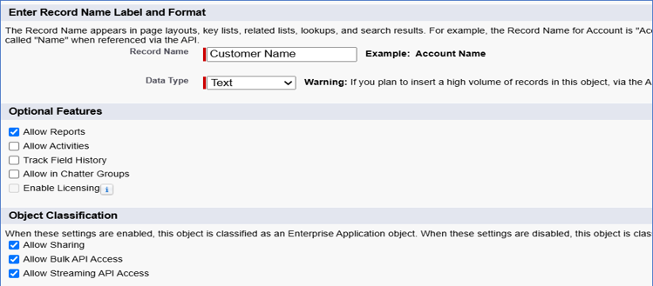

1. Select Allow search.
2. Click on Save and New

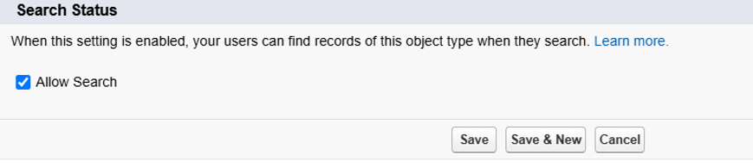**Activity 2: Creating a billing object**

1. Enter the label name--> Billing object.
2. Enter Plural label name --> Billing objects

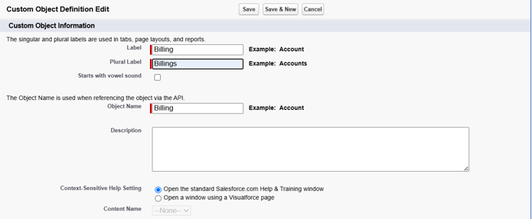

1. Enter Record Name --> Billing No
2. Select Data Type as Auto Number.
3. Format as BILL-{0000}
4. Select Allow reports

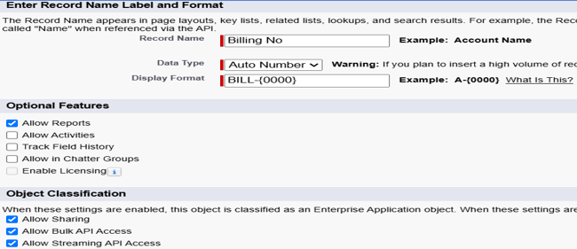

1. Select Allow search.
2. Click on Save and New.

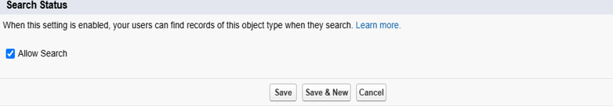

**Activity 3: Creating a Staff Object**

1. Enter the label name--> Staff
2. Enter Plural label name --> Staffs

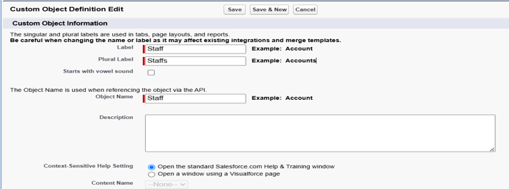

1. Enter Record Name --> Staff Name
2. Select Data Type as Text.
3. Select Allow reports.

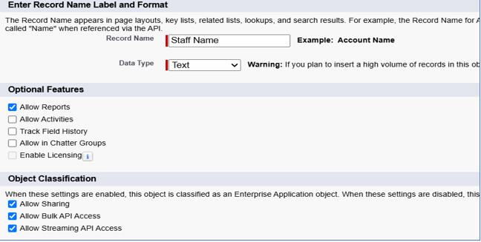

1. Select Allow search.
2. Click on Save

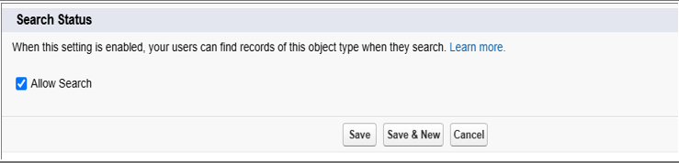

**Milestone 3**

**Tabs**

**Activity 1: Creating a tab for Banquet Hall Object**

1. Go to the setup page --> type Tabs in Quick Find bar
2. Click on tabs.

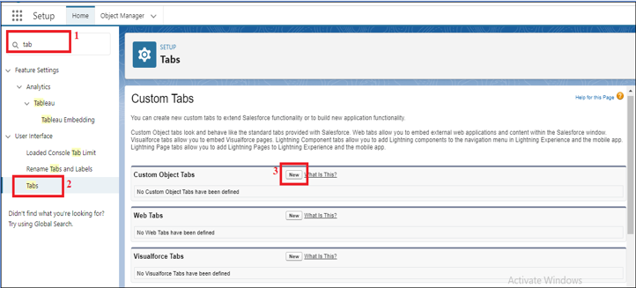

1. Click on New (under custom object tab).
2. Select Object (Banquet Hall) --> Select the tab style
3. Click on Next --> (Add to profiles page) keep it as default -->Click on Next (Add to Custom App) uncheck the include Tab.
4. Make sure that the Append tab to users' existing personal customizations is checked.
5. Click save.

# 

**Activity 2: Creating a tab for Billing Object**

1. Go to the setup page --> type Tabs in Quick Find bar Click on tab.



1. Click on New (under custom object tab).
2. Select Object (Billing) --> Select the tab style
3. Click on Next --> (Add to profiles page) keep it as default -->Click on Next (Add to Custom App) uncheck the include tab.
4. Make sure that the Append tab to users' existing personal customizations is checked.
5. Click save.

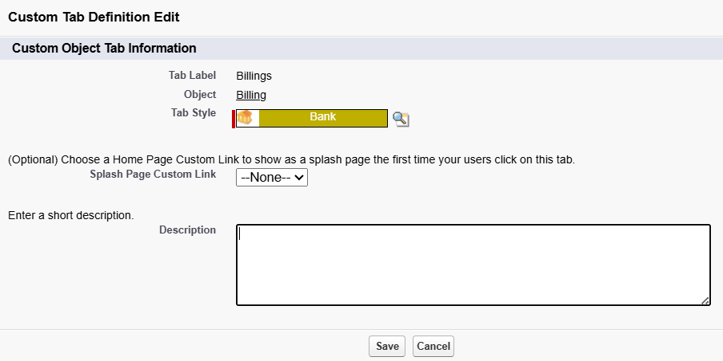

**Activity 3: Creating a tab for staff Object**

1. Go to the setup page --> type Tabs in Quick Find bar
2. Click on tabs.

# 

1. Click on New (under custom object tab).
2. Select Object ( Staff ) --> Select the tab style
3. Click on Next --> (Add to profiles page) keep it as default -->Click on Next (Add to Custom App) uncheck the include tab.
4. Make sure that the Append tab to users' existing personal customizations is checked.
5. Click save.

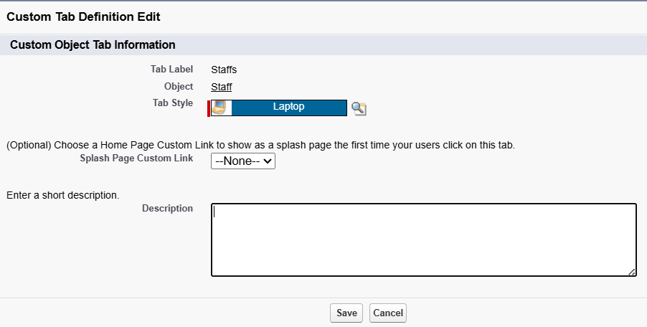

**Milestone 4**

**The Lightning App**

**Activity 1: Create a Lightning App for Banquet Hall Booking**

1. From Setup, enter App Manager in the Quick Find and select App Manager.
2. Click New Lightning App.

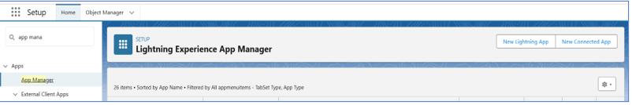

1. Enter Banquet Hall Booking as the App Name, then click next
2. Under App Options, leave the default selections and click next.
3. Under Utility Items, leave as is and click Next.

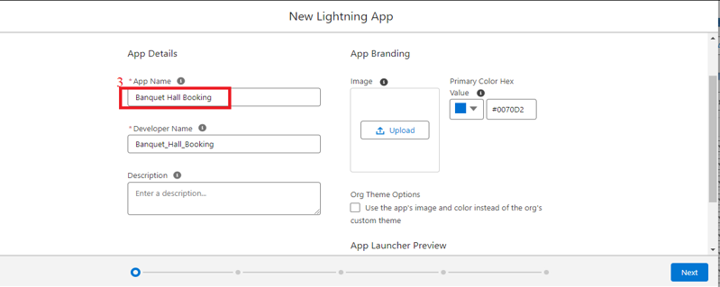

1. From Available Items, select Banquet Halls, Billings, Staff, Reports, and Dashboards and move them to Selected Item and Click Next.

# 

1. From Available Profiles, select System Administrator and move it to Selected Profiles.
2. Click Save & Finish.

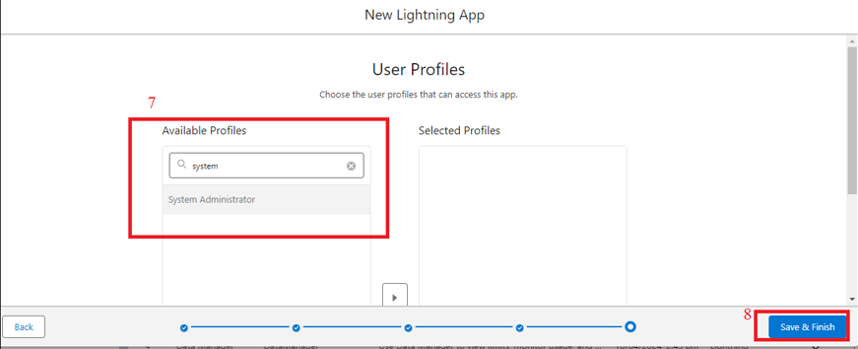

**Milestone 5-**

**Fields**

**Object Name – Banquet Hall**

|  |  |  |  |
| --- | --- | --- | --- |
| **Object** | **Field Name** | **Data Type** | **Required** |
| **Banquet Hall** | Customer Name (Standard) | Text | Yes |
|  | Timings | Picklist (Morning, Evening) | Yes |
|  | Booking Date | Date | Yes |
|  | Decoration Purpose | Picklist | Yes |
|  | Food Menu | Picklist | Yes |
|  | No of Visitors | Number | Yes |
|  | Email | Email |  |
|  | Phone No | Phone |  |
|  | Archestra | Checkbox |  |
|  | DJ | Checkbox |  |
|  | Shehnai and Mridangam | Checkbox |  |
|  | Magician | Checkbox |  |
|  | Kolatam | Checkbox |  |

**Field Name – Timings**

* 1. Go to setup --> click on Object Manager --> type object name (Banquet Hall) in quick find box --> click on the Banquet Hall object.
  2. Now click on “Fields & Relationships”
  3. Click on New.
  4. Select Data type as “picklist” and click Next.
  5. Enter Field Label as “Timings”.
  6. Select Enter values, with each value separated by a new line in Values
  7. Enter Picklist Values (Morning, Evening)
  8. Select Required, always require a value in this field in order to save a record.

1. Click on Next, Next and Save.

.

# 

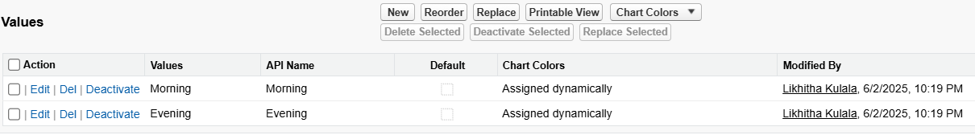

**Field Name – Booking Date**

* 1. Go to setup --> click on Object Manager --> type object name (Banquet Hall) in quick find box --> click on the Banquet Hall object.
  2. Now click on “Fields & Relationships”
  3. Click on New.
  4. Select Data type as “Date” and click Next.
  5. Enter Field Label as “Booking Date”.
  6. Select Required, always require a value in this field in order to save a record.
  7. Click on Next, Next and Save

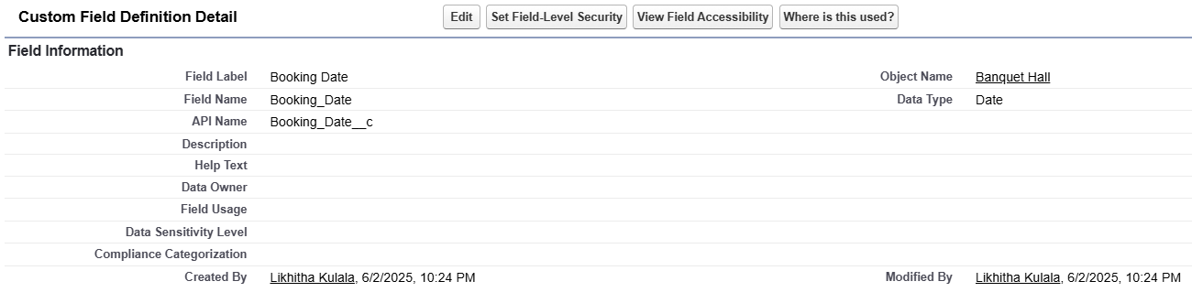

**Field Name - Decoration Purpose**

1. Go to setup --> click on Object Manager --> type object name (Banquet Hall) in quick find box --> click on the Banquet Hall object.
2. Now click on “Fields & Relationships”
3. Click on New.
4. Select Data type as “picklist” and click Next.
5. Enter Field Label as “Decoration Purpose”.
6. Select Enter values, with each value separated by a new line in Values
7. Enter Picklist Values (Reception, Anniversary, Birthday, Other Events)
8. Select Required, always require a value in this field in order to save a record.
9. Click on Next, Next and Save.

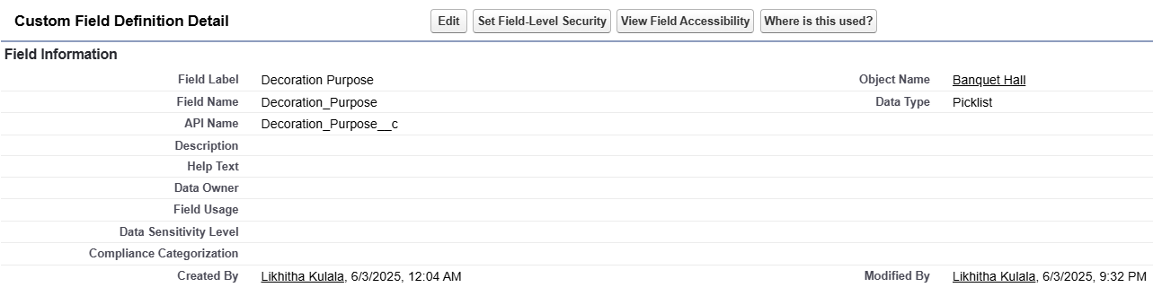

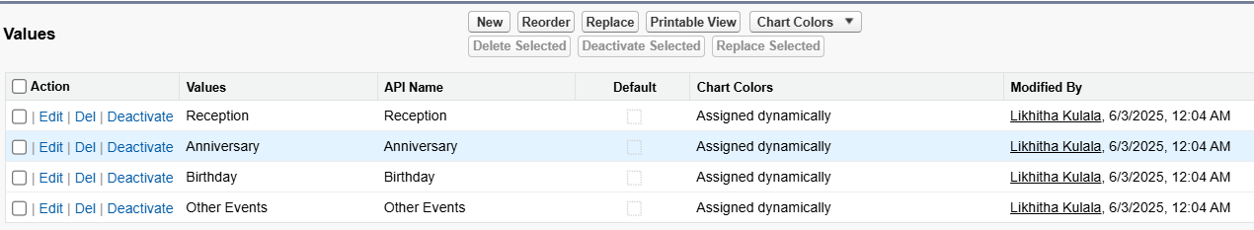

**Field Name - Food Menu**

* 1. Go to setup --> click on Object Manager --> type object name (Banquet Hall) in quick find box --> click on the Banquet Hall object.
  2. Now click on “Fields & Relationships”
  3. Click on New.
  4. Select Data type as “picklist” and click Next.
  5. Enter Field Label as “Food Menu”.
  6. Select Enter values, with each value separated by a new line in Values
  7. Enter Picklist Values (Veg, Special Veg, Non-Veg)
  8. Select Required, always require a value in this field in order to save a record.
  9. Click on Next, Next and Save.

# 

**Field Name – No of Visitors**

1. Go to setup --> click on Object Manager --> type object name (Banquet Hall) in quick find box --> click on the Banquet Hall object.
2. Now click on “Fields & Relationships”
3. Click on New.
4. Select Data type as “Number” and click Next.
5. Enter Field Label as “No of Visitors”.
6. Select Required, always require a value in this field in order to save a record.
7. Click on Next, Next and Save.

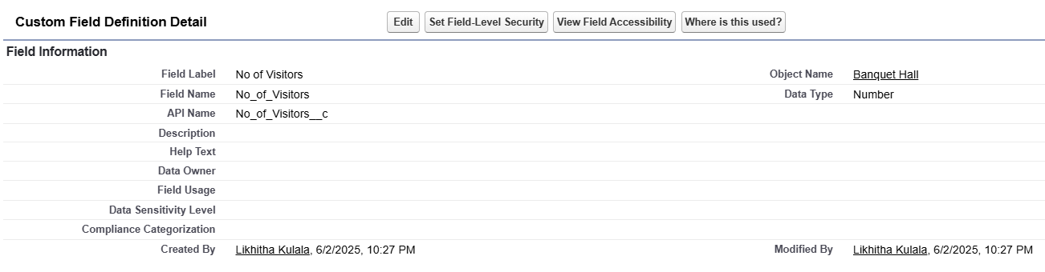

**Field Name – Email**

1. Go to setup --> click on Object Manager --> type object name (Banquet Hall) in quick find box --> click on the Banquet Hall object.
2. Now click on “Fields & Relationships”
3. Click on New.
4. Select Data type as “Email” and click Next.
5. Enter Field Label as “Email”.
6. Click on Next, Next and Save.

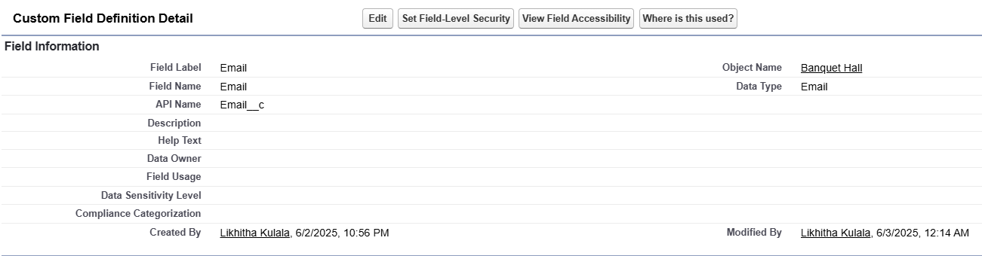

**Field Name – Phone No**

1. Go to setup --> click on Object Manager --> type object name (Banquet Hall) in quick find box --> click on the Banquet Hall object.
2. Now click on “Fields & Relationships”
3. Click on New.
4. Select Data type as “Phone” and click Next.
5. Enter Field Label as “Phone No”.
6. Click on Next, Next and Save.

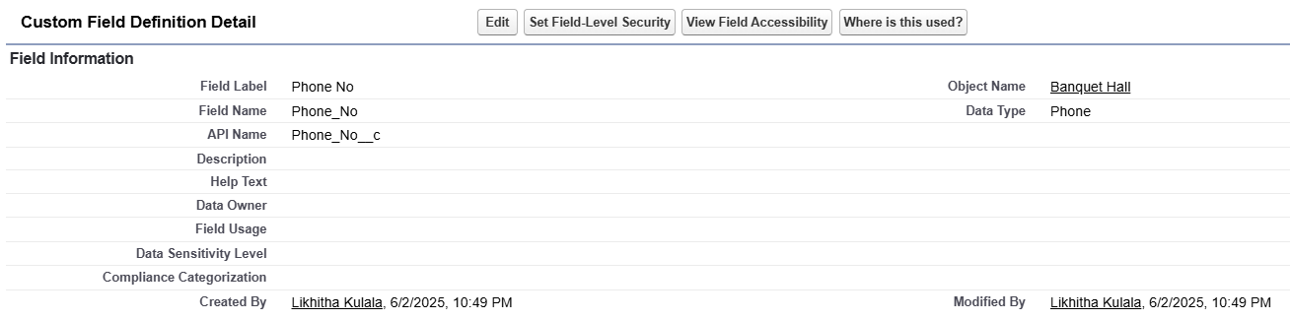

**Field Name – Archestra**

1. Go to setup --> click on Object Manager --> type object name (Banquet Hall) in quick find box --> click on the Banquet Hall object.
2. Now click on “Fields & Relationships”
3. Click on New.
4. Select Data type as “Cheque Box” and click Next.
5. Enter Field Label as “Archestra”.
6. Click on Next, Next and Save.

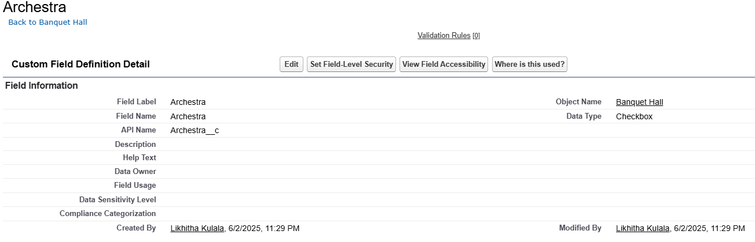

**Field Name – DJ**

1. Go to setup --> click on Object Manager --> type object name (Banquet Hall) in quick find box --> click on the Banquet Hall object.
2. Now click on “Fields & Relationships”
3. Click on New.
4. Select Data type as “Cheque Box” and click Next.
5. Enter Field Label as “DJ”.
6. Click on Next, Next and Save.

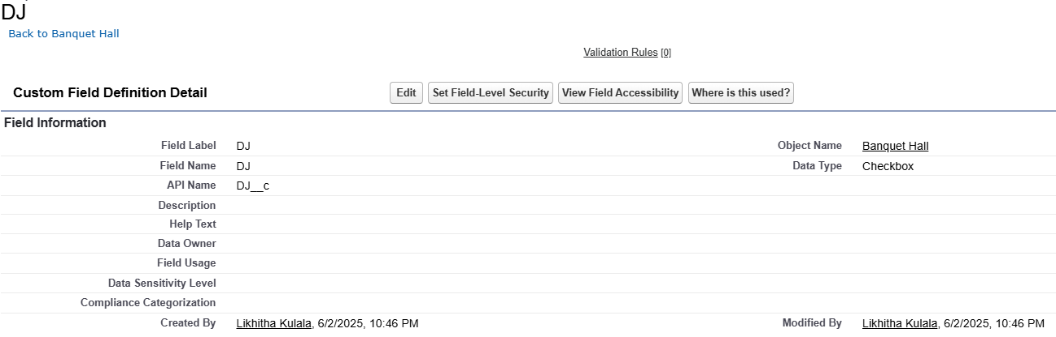

**Field Name - Shenai and Mridangam**

1. Go to setup --> click on Object Manager --> type object name (Banquet Hall) in quick find box --> click on the Banquet Hall object.
2. Now click on “Fields & Relationships”
3. Click on New.
4. Select Data type as “Cheque Box” and click Next.
5. Enter Field Label as “Shenai and Mridangam”.
6. Click on Next, Next and Save.

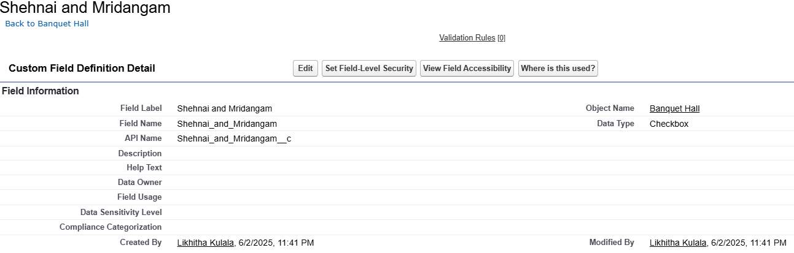

**Field Name – Magician**

1. Go to setup --> click on Object Manager --> type object name (Banquet Hall) in quick find box --> click on the Banquet Hall object.
2. Now click on “Fields & Relationships”
3. Click on New.
4. Select Data type as “Cheque Box” and click Next.
5. Enter Field Label as “Magician”.
6. Click on Next, Next and Save.

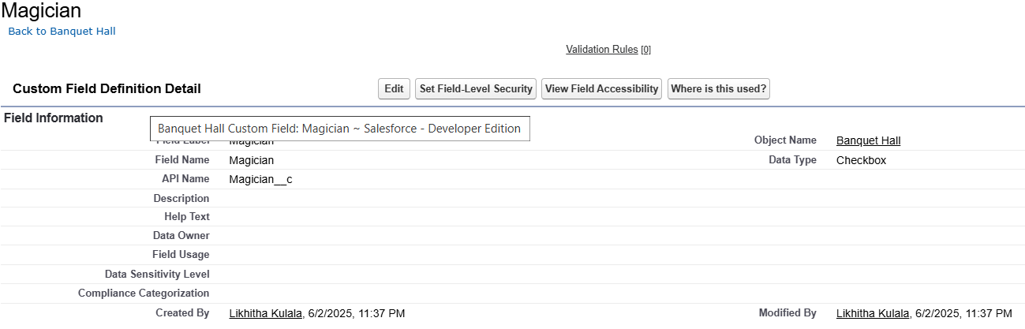

**Field Name – Kolatam**

1. Go to setup --> click on Object Manager --> type object name (Banquet Hall) in quick find box --> click on the Banquet Hall object.
2. Now click on “Fields & Relationships”
3. Click on New.
4. Select Data type as “Cheque Box” and click Next.
5. Enter Field Label as “Kolatam”.
6. Click on Next, Next and Save.

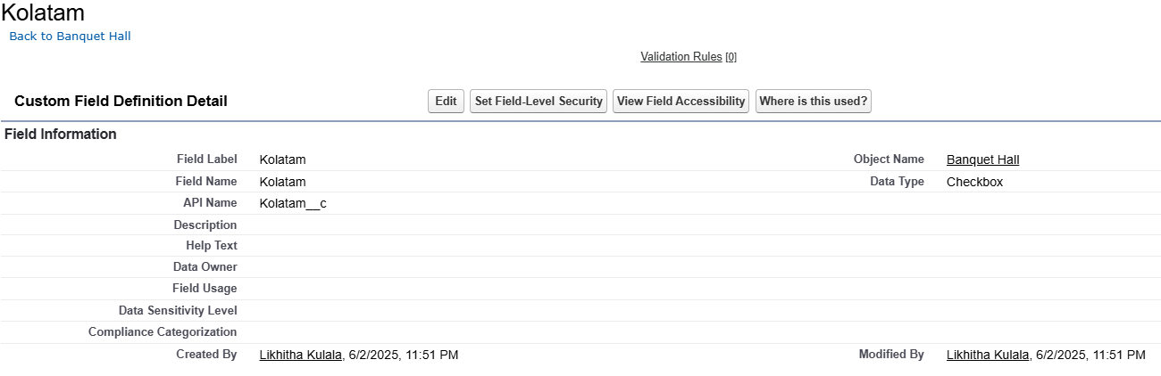

**Object Name – Billing**

|  |  |  |  |
| --- | --- | --- | --- |
| **Object** | **Field Name** | **Data Type** | **Required** |
| **Billing** | Billing No (Standard) | Auto Number  Format: BILL- {0000} | Yes |
|  | Customer Name | Master Detail Relationship with Banquet Hall |  |
|  | Email | Email | Yes |
|  | Food Amount per Plate | Formula |  |
|  | Food Amount | Formula |  |
|  | Decoration Amount | Formula |  |
|  | Archestra Amount | Formula |  |
|  | DJ Amount | Formula |  |
|  | Magician Amount | Formula |  |
|  | Shehnai and Mridangam Amount | Formula |  |
|  | Kolatam Amount | Formula |  |
|  | Total Amount | Formula |  |

**Field Name – Customer Name**

1. Go to the Setup page --> click on Object manager --> type object name (Billing) in the quick find bar--> click on the object.
2. Click on fields & relationship
3. Click on New.
4. Select “Master Detail relationship” as data type and click Next.
5. Select the related object “Banquet Hall”.
6. Click on Next
7. Give Field Label as “Customer Name”.
8. Click on Next --> Next --> Next -->Save

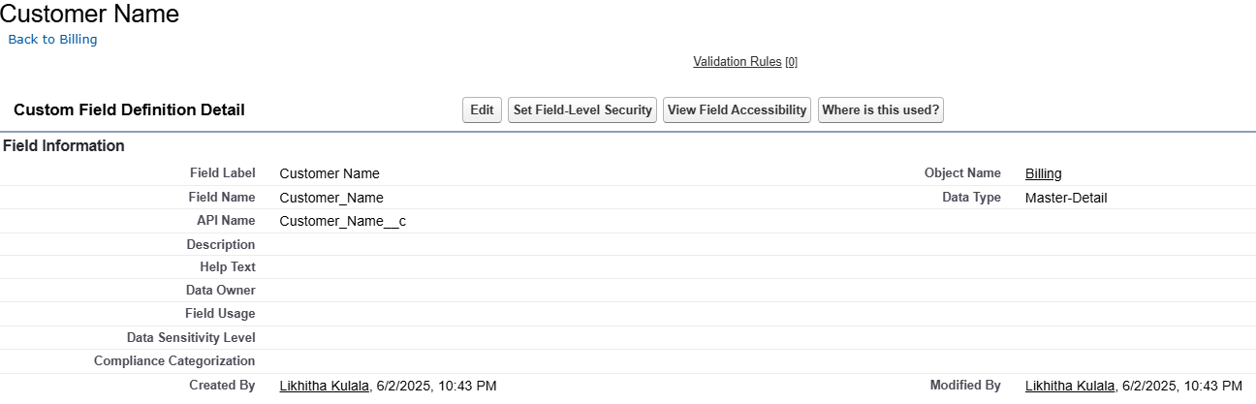

**Field Name – Email**

1. Go to setup --> click on Object Manager --> type object name (Banquet Hall) in quick find box --> click on the Banquet Hall object.
2. Now click on “Fields & Relationships”
3. Click on New.
4. Select Data type as “Email” and click Next.
5. Enter Field Label as “Email”.
6. Select Required, always require a value in this field in order to save a record.
7. Click on Next, Next and Save.

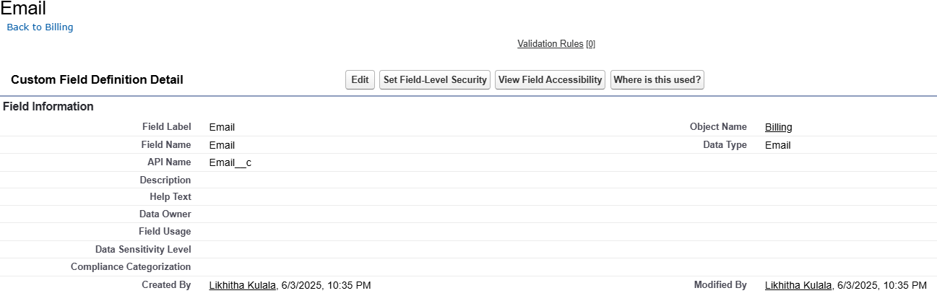

**Field Name –Archestra Amount**

1. Go to setup --> click on Object Manager --> type object name (Billing) in quick find box--> click on the Billing object.
2. Now click on “Fields & Relationships”
3. Click on New.
4. Select Data type as “Formula” and click Next.
5. Enter field label Archestra Amount
6. Select formula return type Currency, Click Next
7. Create and insert Advance formula:  IF (Customer_Name__r. Archestra__c = TRUE, 50000, 0)
8. Click Next, Next, then Save.

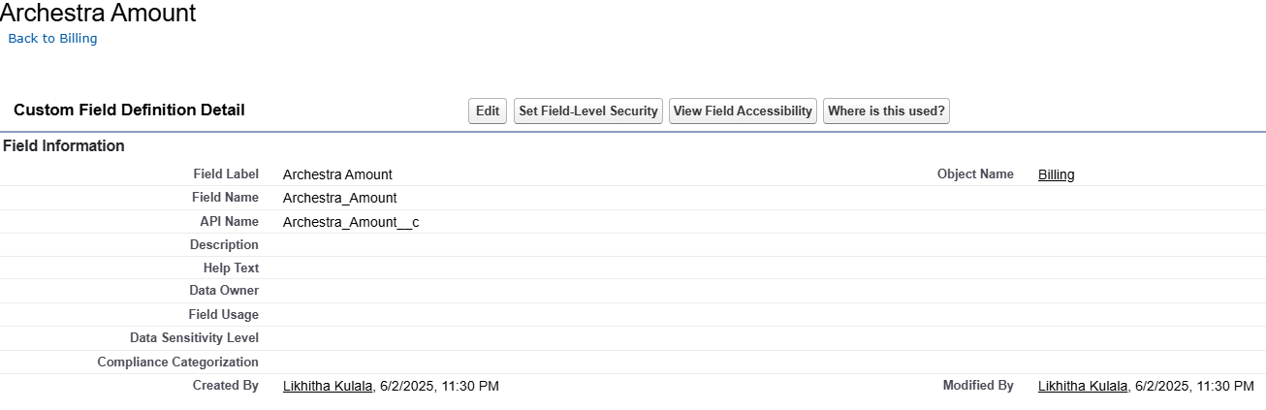

**Field Name - DJ Amount**

1. Go to setup --> click on Object Manager --> type object name (Billing) in quick find box--> click on the Billing object.
2. Now click on “Fields & Relationships”
3. Click on New.
4. Select Data type as “Formula” and click Next.
5. Enter field label DJ Amount
6. Select formula return type Currency, Click Next
7. Create and insert Advance formula:

IF (Customer_Name__r. DJ__c = TRUE, 70000, 0)

1. Click Next, Next, then Save.

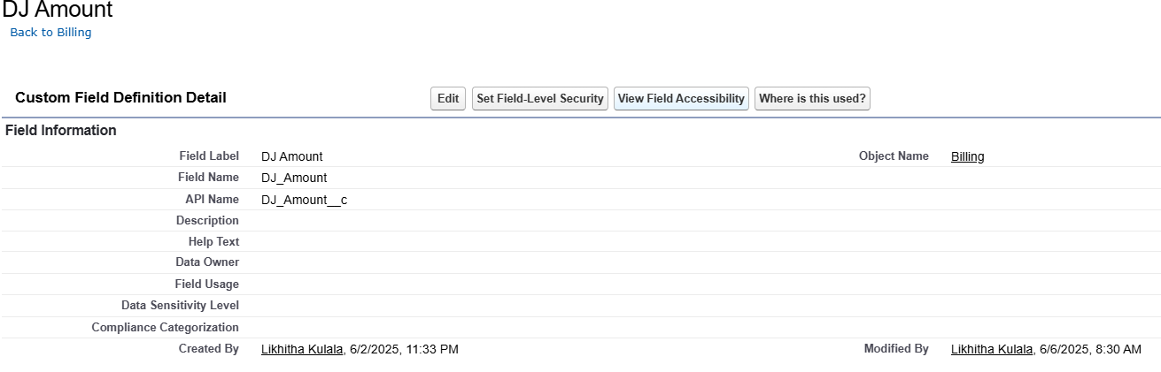

**Field Name - Magician Amount**

1. Go to setup --> click on Object Manager --> type object name (Billing) in quick find box --> click on the Billing object.
2. Now click on “Fields & Relationships”
3. Click on New.
4. Select Data type as “Formula” and click Next.
5. Enter field label Magician Amount
6. Select formula return type Currency, Click Next
7. Create and insert Advance formula:

 IF (Customer_Name__r. Magician__c, 15000, 0)

1. Click Next, Next, then Save.

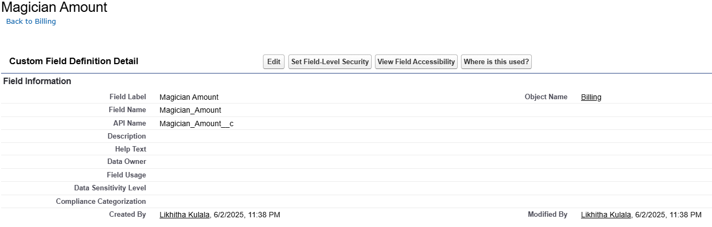

**Field Name - Shenai and Mridangam Amount**

1. Go to setup --> click on Object Manager --> type object name (Billing) in quick find box --> click on the Billing object.
2. Now click on “Fields & Relationships”
3. Click on New.
4. Select Data type as “Formula” and click Next.
5. Enter field label Shehnai and Mridangam Amount
6. Select formula return type Currency, Click Next
7. Create and insert Advance formula:  IF (Customer_Name__r.Shenai_and_Mridangam__c = TRUE, 25000, 0)
8. Click Next, Next, then Save.

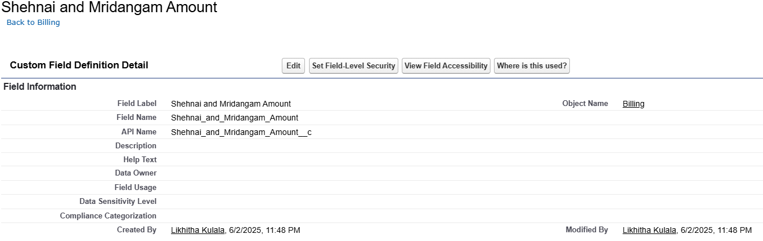

**Field Name - Kolatam Amount**

1. Go to setup --> click on Object Manager --> type object name (Billing) in quick find box--> click on the Billing object.
2. Now click on “Fields & Relationships”
3. Click on New.
4. Select Data type as “Formula” and click Next.
5. Enter field label Kolatam Amount.
6. Select formula return type Currency, Click Next.
7. Create and insert Advance formula: IF (Customer_Name__r. Kolatam__c, 15000, 0)
8. Click Next, Next, then Save.

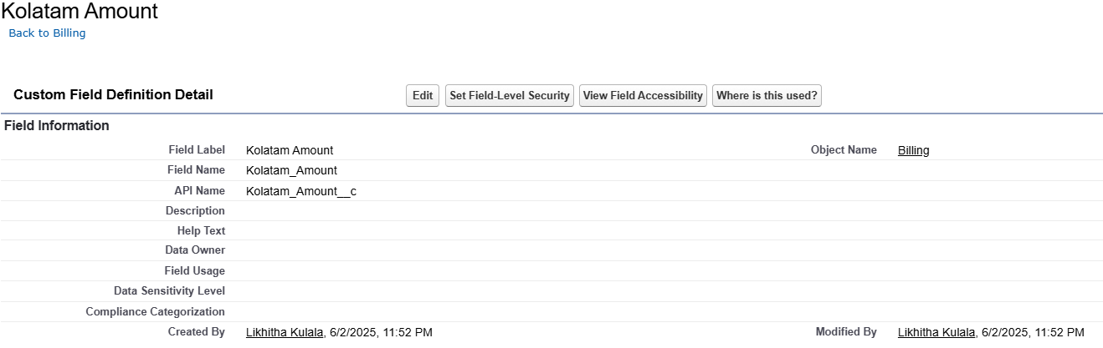

**Field Name - Food Amount per Plate**

1. Go to setup --> click on Object Manager --> type object name(Billing) in quick find box --> click on the Billing object.
2. Now click on “Fields & Relationships”
3. Click on New.
4. Select Data type as “Formula” and click Next.
5. Enter field label Food Amount per Plate
6. Select formula return type Currency, Click Next
7. Create and insert Advance formula as follows:

     CASE (Customer_Name__r. Food_Menu__c, 'Veg', 450,

            'Special Veg', 550,

            'Non-Veg', 550, 650)

1. Click Next, Next, then Save.

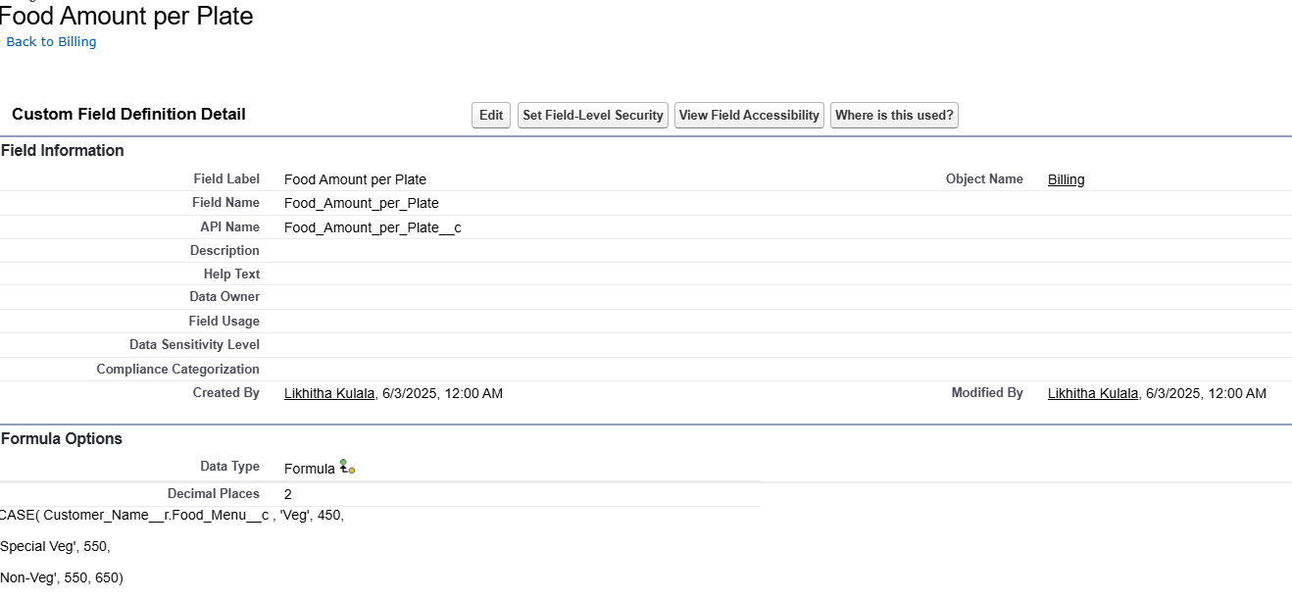

**Field Name - Food Amount**

1. Go to setup --> click on Object Manager --> type object name(Billing) in quick find box--> click on the Billing object.
2. Now click on “Fields & Relationships”
3. Click on New.
4. Select Data type as “Formula” and click Next.
5. Enter field label Food Amount.
6. Select formula return type Currency, Click Next
7. Create and insert Advance formula:

Food_Amount_per_Plate__c   * Customer_Name__r. No_of_Visitors__c

1. Click Next, Next, then Save.

# 

**Field Name - Decoration Amount**

1. Go to setup --> click on Object Manager --> type object name (Billing) in quick find box--> click on the Billing object.
2. Now click on “Fields & Relationships”
3. Click on New.
4. Select Data type as “Formula” and click Next.
5. Enter field label Decoration Amount
6. Select formula return type Currency, Click Next
7. Create and insert Advance formula:

CASE (Customer_Name__r. Decoration_Purpose__c'Marriage', 50000,

       'Reception', 60000,

        'Anniversary', 30000,

       ' Birthday', 25000,

         'Other Events', 20000, 0)

1. Click Next, Next, then Save.

# 

**Field Name – Total Bill Amount**

1. Go to setup --> click on Object Manager --> type object name (Billing) in quick find box--> click on the Billing object.
2. Now click on “Fields & Relationships”
3. Click on New.
4. Select Data type as “Formula” and click Next.
5. Enter field label Decoration Amount
6. Select formula return type Currency, Click Next
7. Create and insert Advance formula:

Decoration_Amount_c + Food_Amountc + DJ_Amountc + Archestra_Amountc + Kolatam_Amountc + Magician_Amountc+ Shehnai_and_Mridangam_Amount_c

1. Click Next, Next, then Save.

# 

**Object Name – Staff**

|  |  |  |  |
| --- | --- | --- | --- |
| **Staff** | Staff Name (Standard) | Text | Yes |
|  | Position | Text |  |
|  | Salary | Currency |  |
|  | Phone No | Phone |  |
|  | Date of Joining | Date |  |

**Field Name – Position**

1. Go to setup --> click on Object Manager --> type object name (Banquet Hall) in quick find box --> click on the Banquet Hall object.
2. Now click on “Fields & Relationships”
3. Click on New.
4. Select Data type as “Text” and click Next.
5. Enter the Field Label as “Position”.
6. Click on Next, Next and Save.

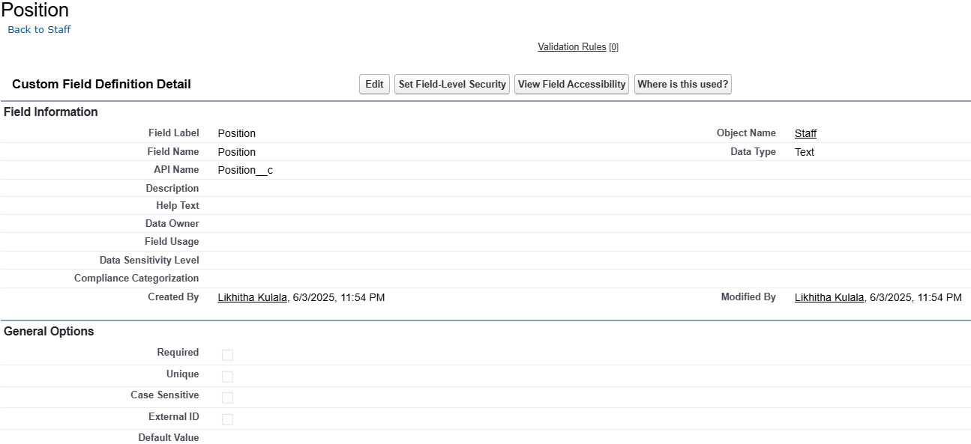

**Field Name - Salary**

1. Go to setup --> click on Object Manager --> type object name (Banquet Hall) in quick find box --> click on the Banquet Hall object.
2. Now click on “Fields & Relationships”
3. Click on New.
4. Select Data type as “Currency” and click Next.
5. Enter the Field Label as “Salary”.
6. Click on Next, Next and Save.

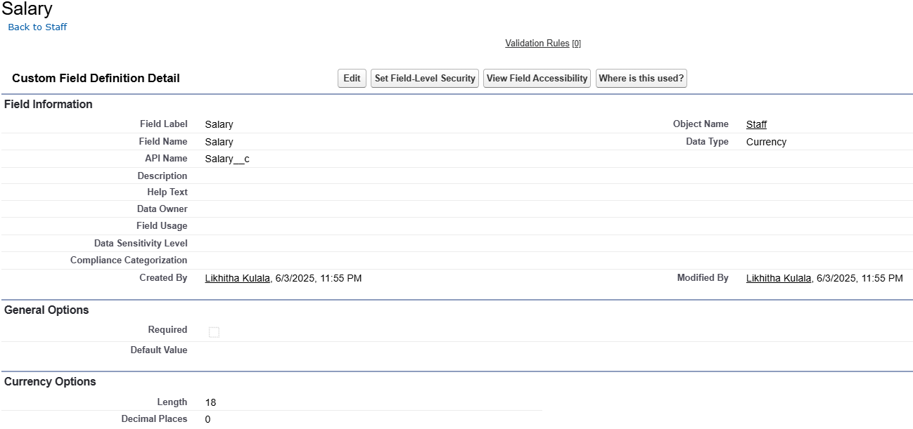

**Field Name - Phone No**

1. Go to setup --> click on Object Manager --> type object name (Banquet Hall) in quick find box --> click on the Banquet Hall object.
2. Now click on “Fields & Relationships”
3. Click on New.
4. Select Data type as “Phone” and click Next.
5. Enter the Field Label as “PhoneNo”.
6. Click on Next, Next and Save.

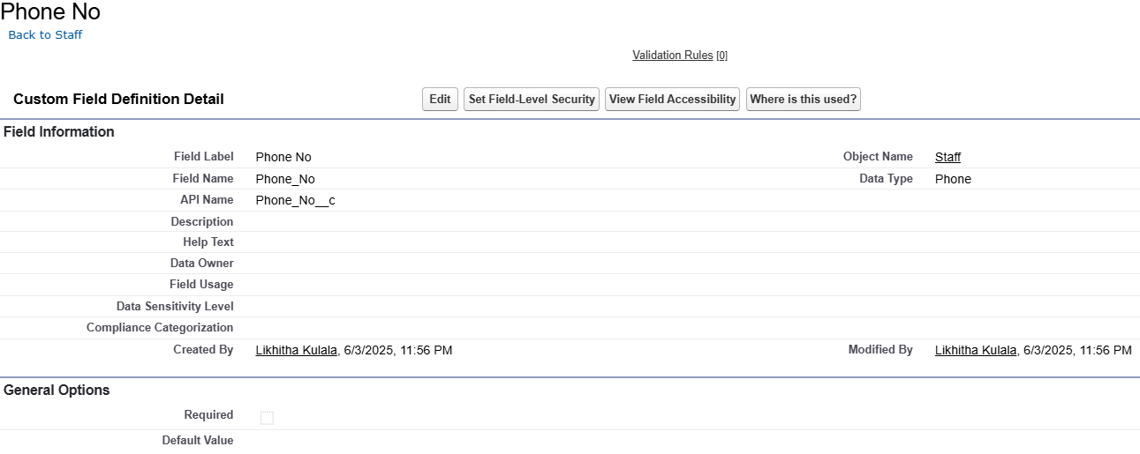

**Field Name - Date of Joining**

1. Go to setup --> click on Object Manager --> type object name (Banquet Hall) in quick find box --> click on the Banquet Hall object.
2. Now click on “Fields & Relationships”
3. Click on New.
4. Select Data type as “Phone” and click Next.
5. Enter the Field Label as “PhoneNo”.
6. Click on Next, Next and Save

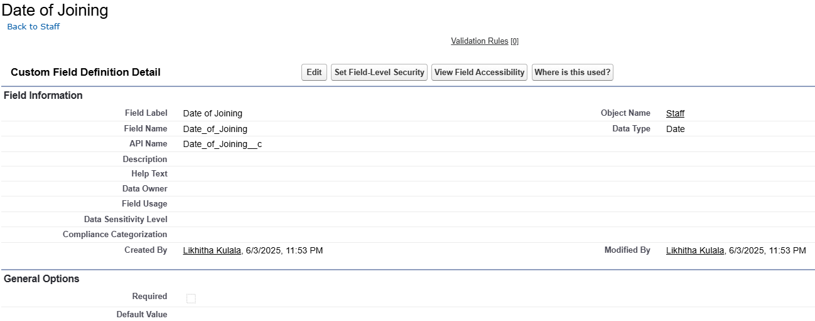

**Milestone 6**

**Creation of Page Layouts**

**Activity 1: To create a Page Layout in Banquet Hall Object for Official Booking**

1. Go to setup --> click on Object Manager --> type object name (Banquet Hall) in quick find box --> click on the Banquet Hall object.
2. Click on the Page Layouts
3. Click on New.

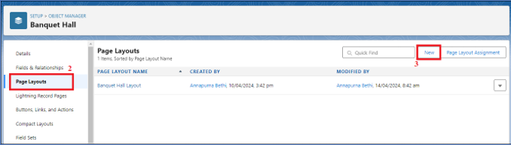

1. Enter details as

* Existing Page Layout: Select Banquet Hall Layout
* Page Layout Name: Official Booking
* Click on Save

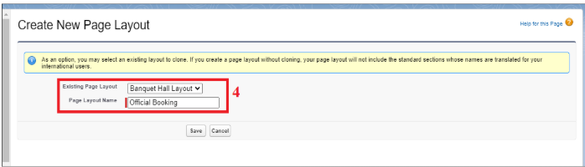

1. Drag and arrange the field as shown below

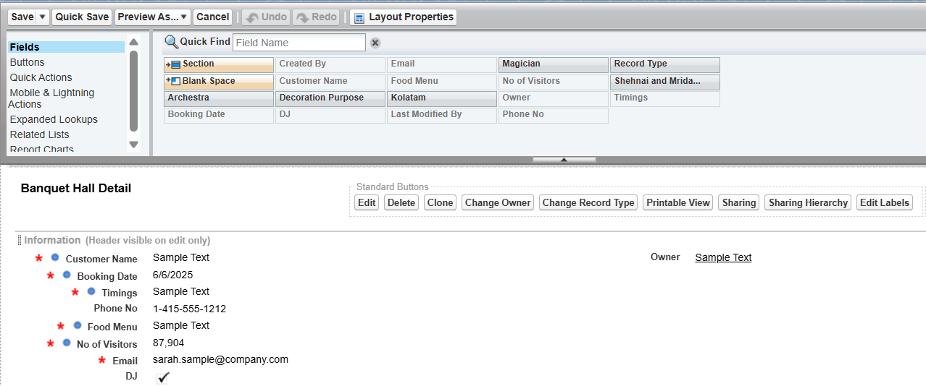

**Activity 2: To create a Page Layout in Banquet Hall Object for Celebrations**

1. Go to setup --> click on Object Manager --> type object name (Banquet Hall) in quick find box--> click on the Banquet Hall object.
2. Click on the Page Layouts
3. Click on New.



1. Enter details as

* Existing Page Layout: Select Banquet Hall Layout
* Page Layout Name: Celebrations
* Click on Save

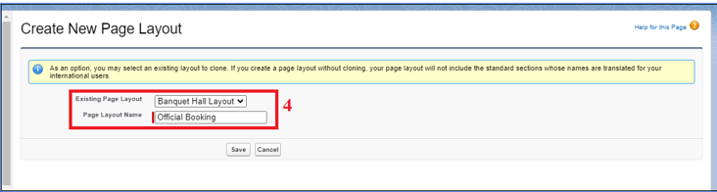

1. Drag and arrange the field as shown below

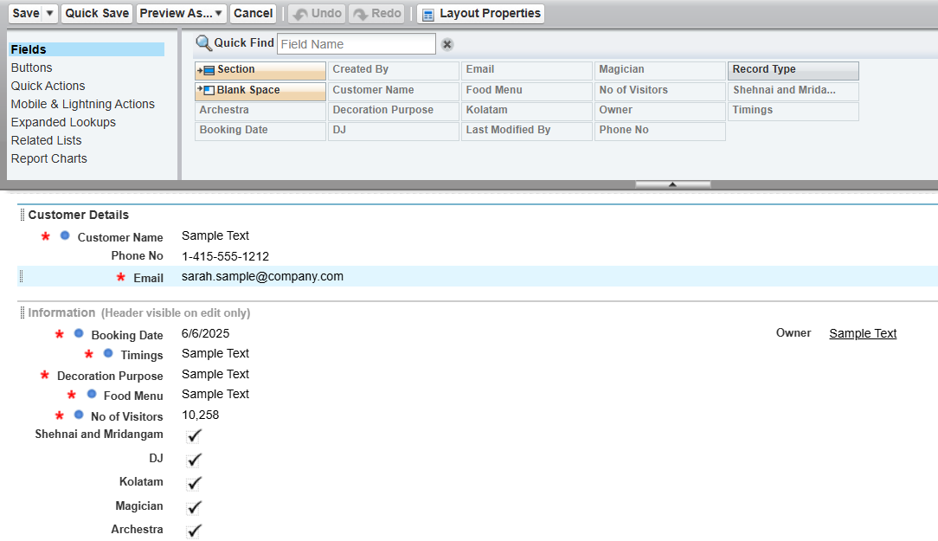

**Milestone 7**

**Creation of Record Types**

**Activity 1: To create a Record Type for Official Booking in Banquet Hall Object**

1. Go to setup --> click on Object Manager --> type object name (Banquet Hall) in quick find box --> click on the Banquet Hall object.
2. Click on the Record Types.
3. Click on New.

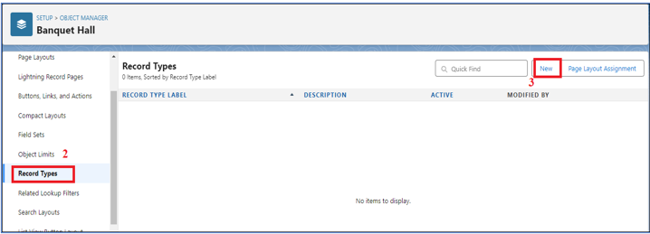

1. Enter the details: For Record Types

* Existing Record Types: Master
* Record Type Label: Official Booking
* Record Type Name:  Official_ Booking
* Active: Tick checkbox

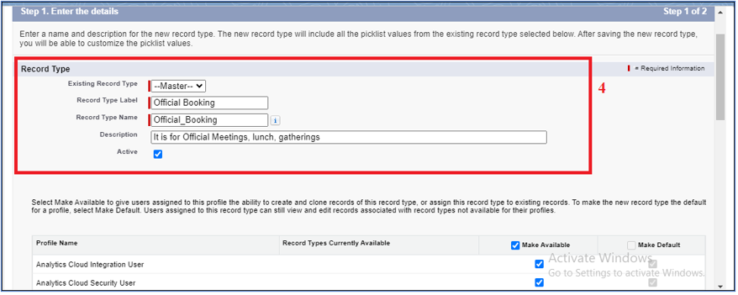

1. Click on Next
2. In Assign Page Layout

* Apply one layout to all profiles: Select Official Booking

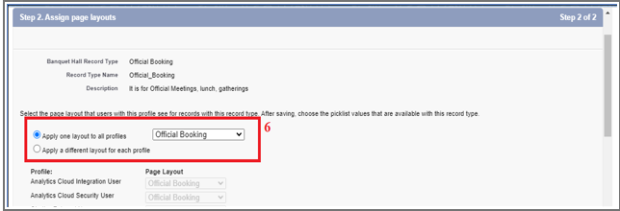

1. Click on Save.

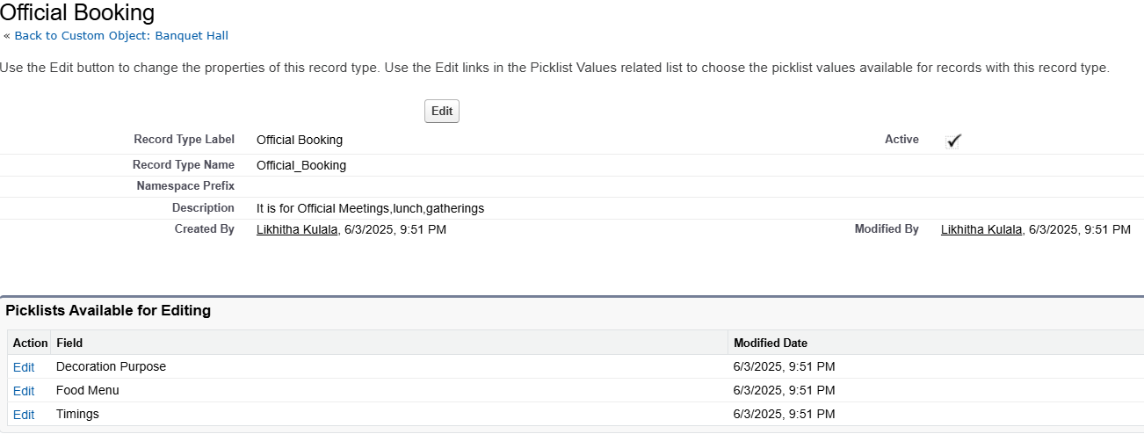

**Activity 2: To create a Record Type for Celebrations in Banquet Hall Object**

1. Go to setup --> click on Object Manager --> type object name(Banquet Hall) in quick find box--> click on the Banquet Hall object.
2. Click on the Record Types.
3. Click on New.



1. Enter the details: For Record Types

* Existing Record Types: Master
* Record Type Label: Celebrations
* Record Type Name: Celebrations
* Active: Tick checkbox.

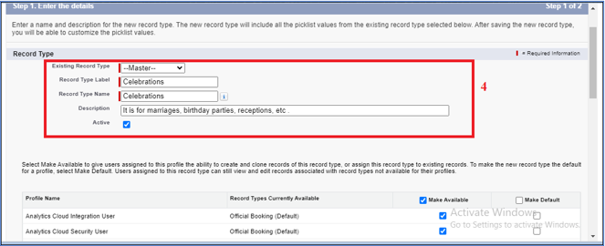

1. Click on Next
2. In Assign Page Layout
   * Apply one layout to all profiles: Select Celebrations

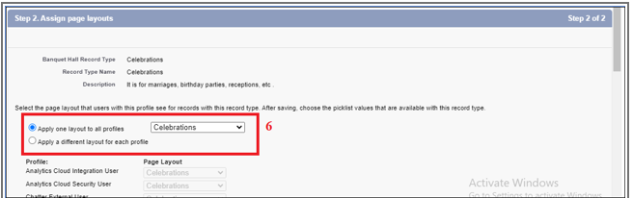

1. Click on Save.

# 

**Milestone 8**

**Validation Rules**

**Activity 1: To create a validation rule to an Banquet Hall Object**

1. Go to setup --> click on Object Manager --> type object name (Banquet Hall) in quick find box--> click on the Banquet Hall object
2. Click on the validation rule --> click on New.
3. Enter the Rule name as “BookingDateChecking”.
4. Select Active
5. Insert the Error Condition Formula as:  
   Booking_Date__c <= TODAY ()

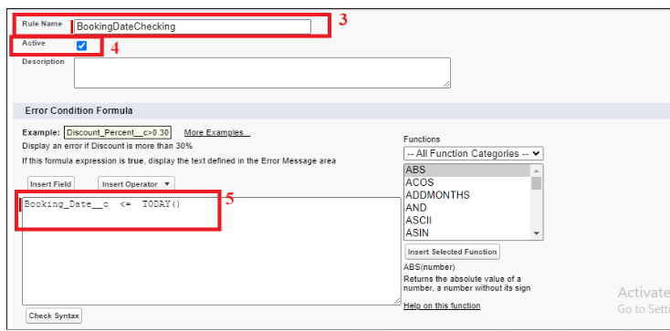

1. Enter the Error Message as “Booking Date must be a future Date”.
2. Select the Error location as Field and as Booking Date and click Save.

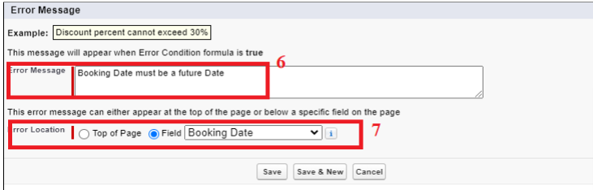

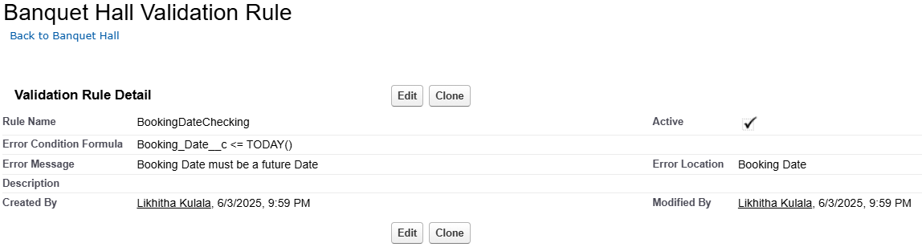

**Milestone 9**

**Flows**

**Activity 1: Create Flow to check whether the same booking date and timings are already available.**

1. Go to setup --> type Flow in quick find box --> Click on the Flow and Select the New Flow.
2. Select the record Triggered flow. Click on create.

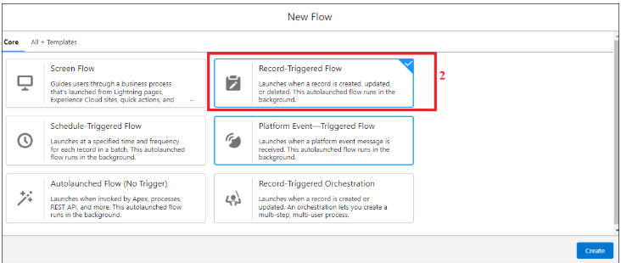

1. Under Object select “Banquet Hall”
2. Select A record is created.

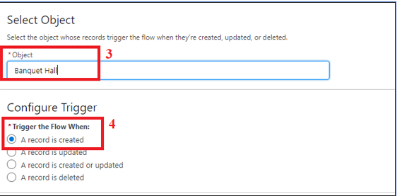

1. Set Entry Conditions: None
2. Select Fast Field Updates.

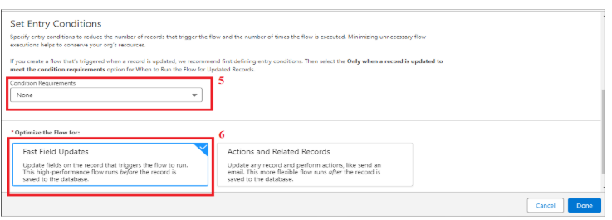

1. Under the record trigger flow click on the “+” icon and select Get Records.
2. Enter Label as “Duplicate Checking for Banquet Hall”.
3. For Object select Banquet Hall.

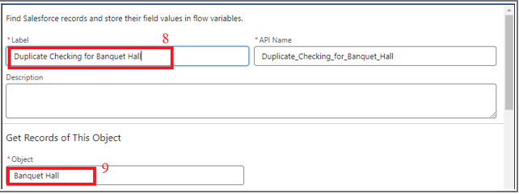

1. For Condition Requirements, select All Conditions are Met (AND)

        10a.      For the first condition select as follows:

                                 Field: Booking_Date__c

                                 Operator: Equals

                                        Value: {! $ Record. Booking _Date__c}

         10b.    For the second condition select as follows:

                     Field: Timings__c

                                 Operator: Equals

                                        Value: {! $ Record. Timings __c}

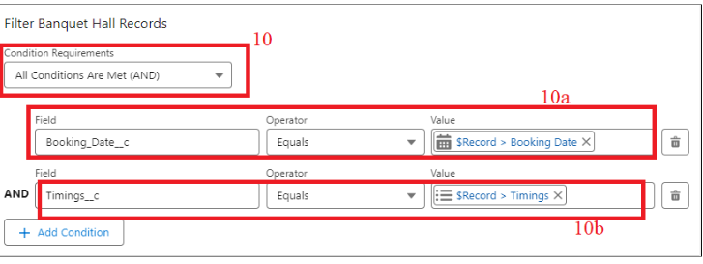

1. For How many Records to store Select All Records.
2. For How to Store Record Data select Choose Automatically Store All Fields. Click on Done.

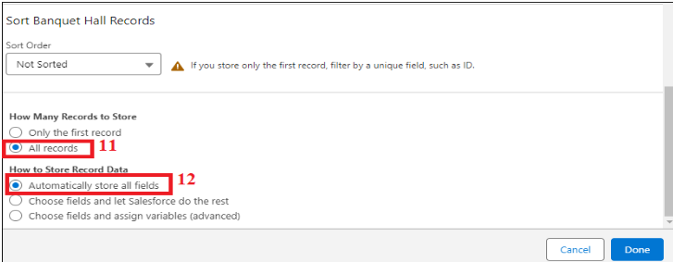

1. From the Toolbox drag and drop Decision element.
2. Enter the Decision label as “Duplicate Checking on Banquet Hall”.
3. For Outcome Details:

* Label: BookingSlotChecking
* Outcome API Name: BookingSlotChecking
* Condition Requirements to Execute Outcome: All Conditions are Met (AND)
* Resource: {!Duplicate_Checking_for_Banquet_Hall}
* Operator: Is Null
* Value: {!$GlobalConstant.False}

# 

1. Click Done
2. From the Toolbox drag and drop Custom Error Message element.
3. Enter the label as “Banquet Hall Booking Error Message”.
4. For Where to Show the Error Message: Select In a window on a record page

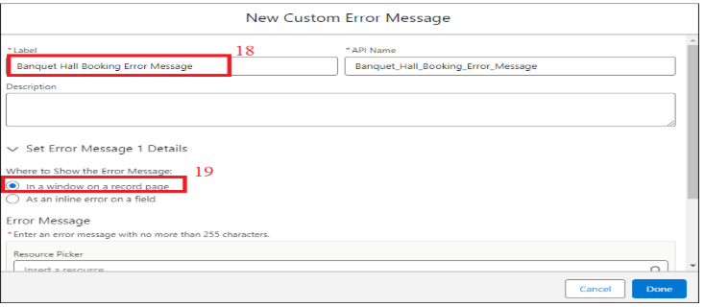

20. Error Message: On {!$Record.Booking_Date__c}, in the {!$Record.Timings__c} the Banquet Hall is not Available for Booking.

# 

1. Click Done
2. Save the flow as “Banquet Hall Booking Availability Checking”
3. Activate the flow.

**Milestone 10**

**Triggers**

**Activity 1: Create a Trigger for Automated Billing Creation upon Banquet Hall Creation**

Step 1 : Login to Salesforce:

Log in to your Salesforce account with administrative privileges.

Step 2:

i)Navigate to Setup: Once logged in, click on the gear icon  (Setup) located at the top-right corner of the page. This will open the Setup menu.

ii)Click on Developer Console: Click on the "Developer Console" option from the Setup menu.   This will open the Developer Console in a new browser tab or window.

Step 3:

1) In the Developer Console window, go to the top menu and click on "File".

2)Select New: From the dropdown menu under "File", select "New".

3)Choose Apex Class: In the submenu that appears, select "Apex Class". This will open a new Apex Class editor tab.

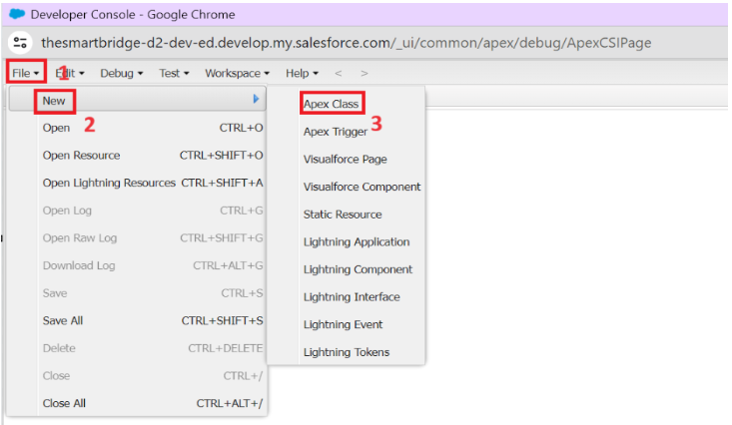

**Give Class Name**: BillingTriggerHandlerClass

**Create an Apex Class**:

public class BillingTriggerHandlerClass {

    Public Static Void BillingCreationonBooking(List<Banquet_Hall__c> bHallList) {

        List<Billing__c> billList = new List<Billing__c> ();

        For (Banquet_Hall__c bHall: bHallList) {

            Billing__c bil = new Billing__c();

            bil.Customer_Name__c =bHall.Id;

            bil.Email__c = bHall.Email__c;

            billList.add(bil);

        }

        If (!billList.isEmpty()) {

            insert billList;

        }

    }

}

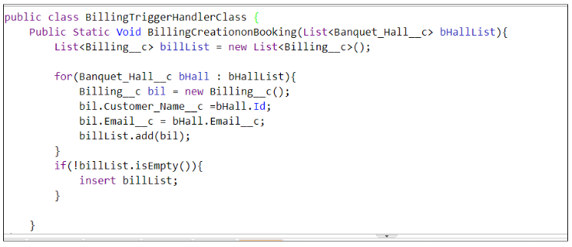

Step 4:

i) In the Developer Console window, go to the top menu and click on "File".

ii)Select New: From the dropdown menu under "File", select "New".

iii)Choose Apex Class: In the submenu that appears, select "Apex Trigger". This will open a new Apex Trigger editor tab.

**Create an Apex Trigger**:

trigger BillingRecordCreation on Banquet_Hall__c (after insert) {

   if(trigger.isInsert) {

        if(trigger.isAfter) {

            BillingTriggerHandlerClass.BillingCreationonBooking(trigger.new);

        }

    }

}

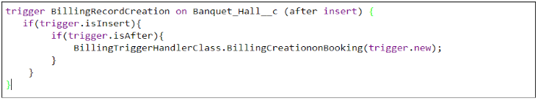

**Milestone 11**

**Reports**

**Activity 1: Create a Summary Report**

1.Click App Launcher  
2. Select Banquet Hall Booking App  
3.  Click Reports tab  
4.  Click New Report.  
5.  Click the report type as Banquet Halls with Billings Click Start report.

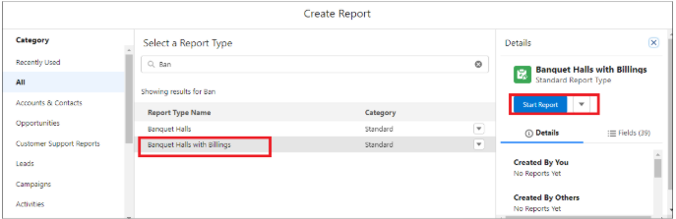

6.Click on Filters and select as follows and click on Apply

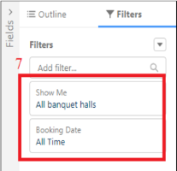

7. Customize your report, in group rows select – Booking Date, for columns Timings, Total Bill Amount (In this way we are making a Summary Report).  
8.  Click save and run.  
9. Give report name – Banquet Halls with Billings Report  
10. Click Save

NOTE: In this report you can see your all record of the object you selected for reporting

(What you select in “Select a report type option”)

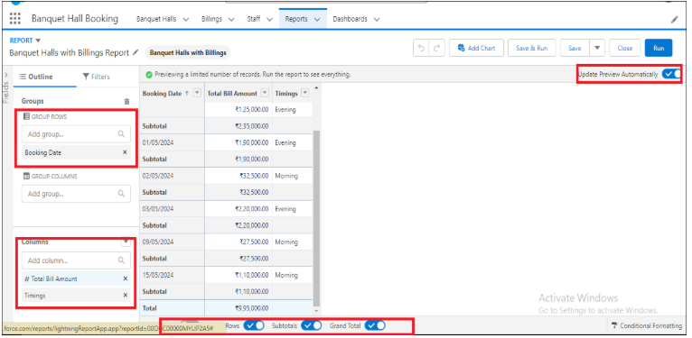

**Activity 2: View Report**

1.   Click on App Launcher on the left side of the screen.

2.   Search Banquet Hall Booking App & click on it.

3.   Click on Reports Tab.

4. Click on Banquet Halls with Billings Report and see records.

**Milestone 12**

**Dashboards**

Activity 1: - Create Dashboard

1. Click on the Dashboards tab from the Banquet Hall Booking application.  
2.  Click on the new dashboard.  
3.  Give name - Total Revenue   
4.  Click create

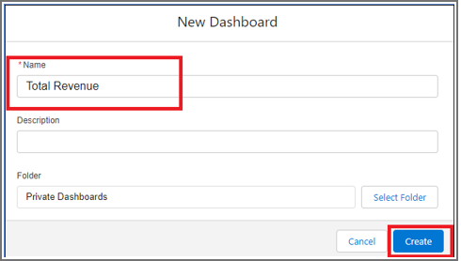

5.  Give your dashboard a name and click on +widget

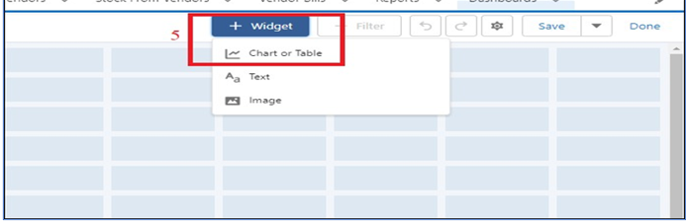

6.Select the Banquet Halls with Billings Report.

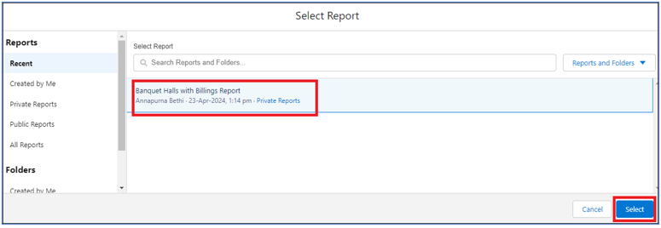

1. For the data visualization select any of the charts, tables etc. as per your choice/requirement.
2. Click add.
3. Click save.

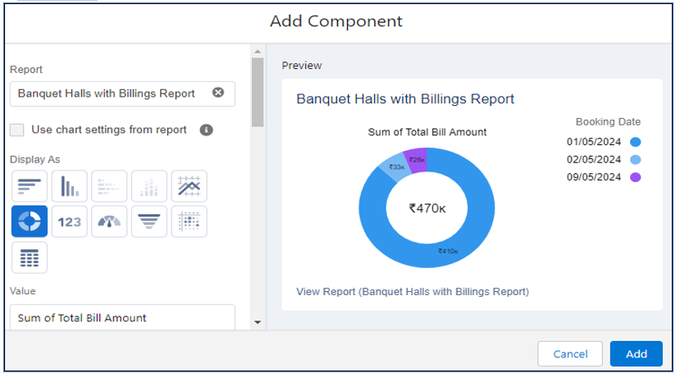

**Activity 2: View Dashboard**

1. Click on App Launcher on the left side of the screen.  
2. Search Banquet Hall Booking & click on it.  
3. Click on Dashboard Tab.  
4. Click on Total Revenue see graph view of records

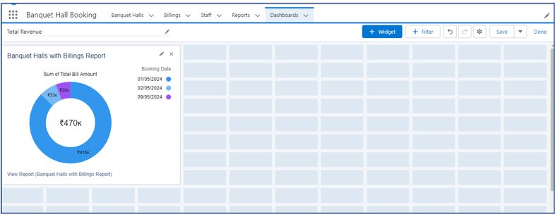

**Outputs:**

Banquet Halls Click New

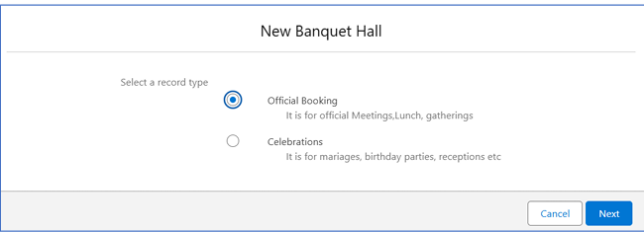

Select one option (Official Booking)

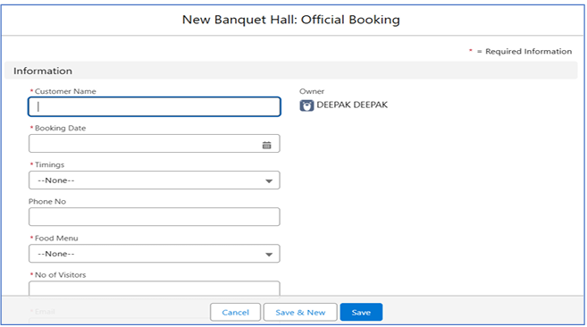

Select another option (Celebrations)

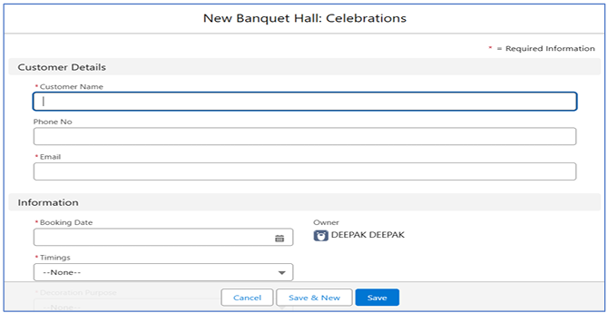

Billing section click New

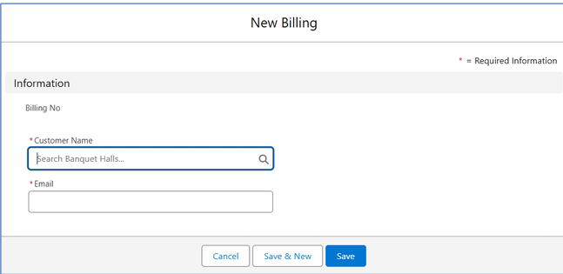

Staffs section Click New

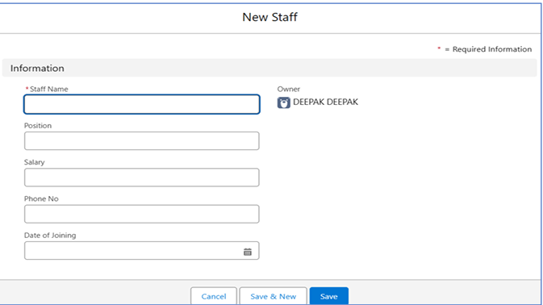

Reports screen

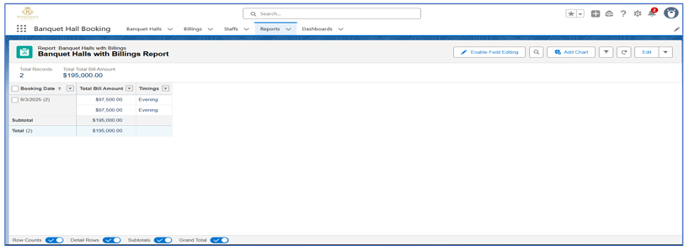

Dashboards screens

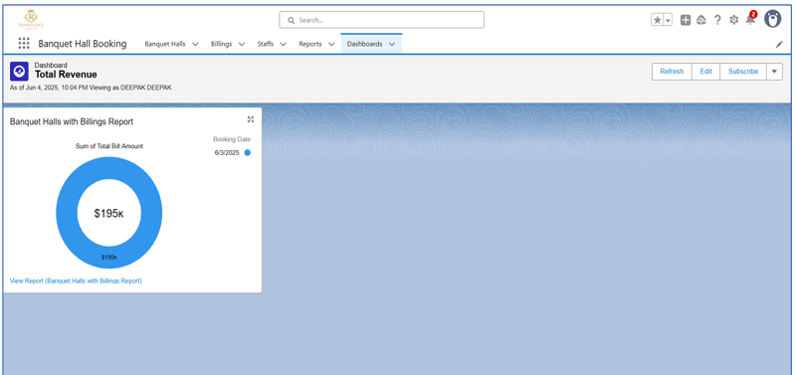

**Milestone 13**

**Conclusion**

By implementing the enhanced Banquet Hall Booking Management System in Salesforce, the venue can offer a seamless experience for clients seeking banquet hall services, catering/menu options, DJ services, decorations, and marriage-related services. This comprehensive solution will streamline operations, enhance customer experience, and drive revenue growth through efficient booking management and personalized service delivery.